ANACONDA SADDLE CLUB, INC.
2024

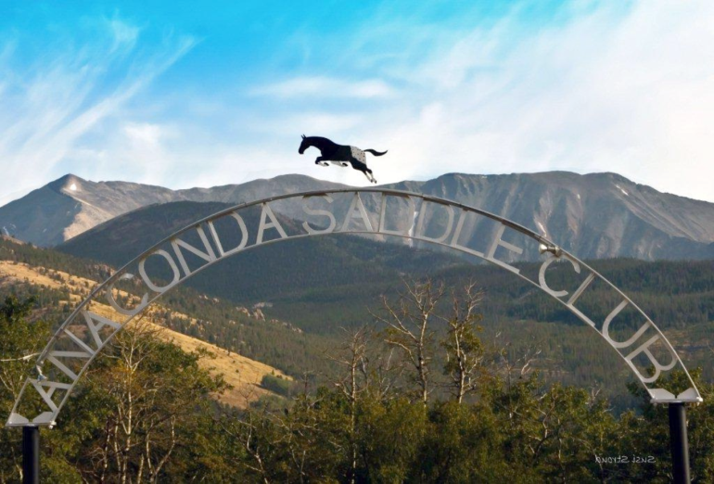

Member National Register
of
Historic Places

TABLE OF CONTENTS

Table of Contents/Schedule of Charges 1
Poem 2
Welcome Letter 3
Constitution of the ASC 4-6
By-Laws of the ASC 7-11
Ground Rules of the ASC 12-15

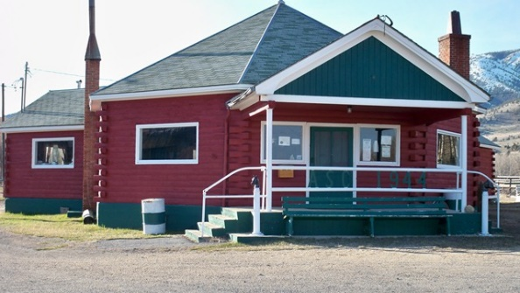

SCHEDULE OF CHARGES

DUES/FEES | 1/1/2024
Initiation Fee ~ One Time for all memberships | $50.00
Membership Dues ~ Annual | $100.00
Associate Membership ~ Annual | $30.00
Non-Voting Competition Membership | $20.00/person  $35.00/family
Lease Fee for Barn Space | $150.00
** Tank Heater Charge per Heater per Season | $90.00**
Late Fee/Month | $3.00

**$90.00 minimum, subject to change per Ground Rule #20, Page #15

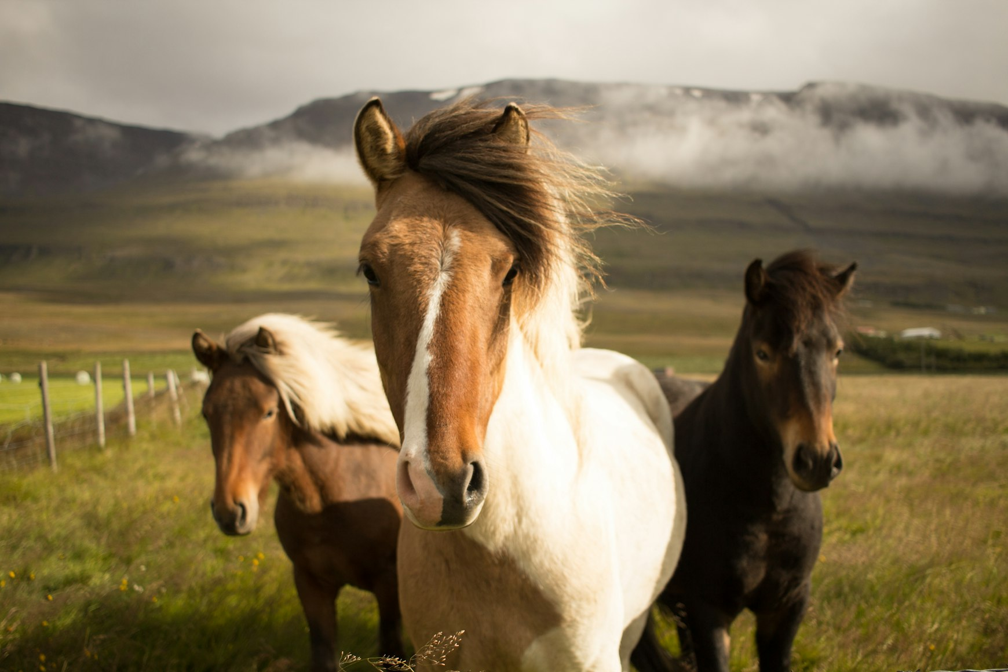

ANACONDA SADDLE CLUB, INC.

81 Saddle Club Drive

ANACONDA, MT 59711

Dear Anaconda Saddle Club Member:

The Anaconda Saddle Club Broad of Directors and Officers are very happy to present this handbook to you. The handbook contains the Constitution, By-Laws, Ground Rules, dues/fees list, current barn owner’ list, and current membership list of our organization.

We believe that it is very important that the membership be informed of the Saddle Club’s rules and regulations, so that we can all enjoy our shared passion of horses in a safe and constructive manner. Please pay special attention to the Ground Rules, as they govern our day-to-day conduct on Saddle Club Property.

We would also like to encourage all of you to attend the monthly membership meetings, on the second Thursday of each month at 7:00 p.m., in the ASC Clubhouse. Your participation and input is very important to the future of this organization.

Together we hope to improve our facility, provide some quality education and most importantly, we look forward to a fun-filled summer of horse activities and events.

Sincerely,

Officers: Board Members:

Kristie Vauthier, President Annie Williams, (3 yr-2023 – 24 – 25)

Jeremy Williams, Vice President Skyler McNeal (2 yr-2023 – 24)

Rita Sorum, Treasurer Kyron King (1 yr-2024)

Cyndi Thompson, Secretary

Events Committee (including but not limited to): Rita Sorum, Kristie Vauthier, Cyndi Thompson, Annie Williams.

Grievance Committee (including but not limited to): Board of Directors.

CONSTITUTION of the
ANACONDA SADDLE CLUB, INC.

- Purpose: The Anaconda Saddle Club is formed as a non-profit corporation for the purpose of promoting interest in horses through good horsemanship, training, education, and horse related activities.

- Officers: There shall be a president, vice-president, secretary, treasurer, and three persons to serve as the board of directors. These officers and directors shall be known as the corporate officers of the Club. All shall be elected by a majority vote of the participating members in attendance at each December meeting except that the outgoing president will serve the one-year term on the board of directors. This body of seven members shall have jurisdiction over the management and operation of the organization.

- Membership: Three types of membership are available.

“Full Participating” membership in the ASC includes individual memberships and family memberships. Individuals (non family members) who use the facility on a regular basis to ride or train horses whether they own a horse or not must be a participating member. A family membership is defined as a traditionally married husband, wife, and children under the age of 18.

“Associate” memberships are available to individuals who do not own a horse wishing to support the A.S.C., or friends/family of full participating members who do not own a horse, but have access to member’s horses and wish to use the facility. At any time that an Associate Member purchases a horse and wishes to continue using the facility, they must up grade their membership to “Full Participating” whether or not they house the horse at the ASC. Associate members may not own barns. An associate membership in the ASC includes individual memberships and family memberships. An associate membership is defined as a traditionally married husband, wife, and children under the age of 18.

“Non-voting Competition Membership” in the ASC is available for competition purposes; i.e., if an individual must belong to a club/organization to compete in an event. This membership is available for individual membership and family memberships (traditionally married husband, wife, and children), is excluded from submitting a membership application at a meeting and the probationary period, and does not carry a vote.

- Dues: Participating members and associate members shall pay dues annually. Membership shall include a person and his or her immediate family with the exception of those family members over 18 years of age. The dues will be used exclusively for the maintenance and expansion of the Club and shall be spent by the authority of the corporate officers.

- Policy: It shall be the policy of the Club to create interest and pleasure in horses and encourage good horsemanship, first in the membership and second for the public. The Club shall aid its members in choosing good horses, encouraging ownership, and developing good horsemanship skills. No member shall charge for his or her services for Club activities unless the service would cost the individual member and benefit the entire Club. Each member shall strive to interest others in horses. Guests of Club members will be paid for by their host if attending Club functions and not out of Club funds, unless the Club chooses to do so.

- Election of Officers: Nomination of officers will be held during the November monthly meeting. Election of officers will be held in December of each year. Members wishing to serve on the board or as an officer shall be in good standing for one year before being eligible. Any member nominated for an office must be present at the December meeting in order to be elected. New officers and directors will assume their offices as of the first meeting in January. Regular elections will be by a majority vote of the membership attending the December meeting. In the event of a vacant office, the remaining corporate officers will fill the position from the general membership. The appointed officer will serve only until the next annual election.

- Grievances: Any member having a grievance shall report it to the “grievance committee” who shall work with the parties involved to resolve the grievance in accordance with the language set forth in the ASC Handbook. If the grievance is not addressed in the language set forth in the ASC Handbook then it will fall to the corporate officers who will have full power to settle or adjust the grievance at their direction.

- Committees: The President shall appoint members to serve on committees as it becomes necessary to carry on work for the betterment of the Club.

- New Members: Persons desiring membership in the Club must do so by filling out an application for membership and submitting it at any regular monthly meeting. The perspective new member will serve a 1-month’s probationary membership with use of the ASC facility. The new member will be approved or disapproved for membership into the ASC at the following month’s meeting unless special circumstances arise at which time the corporate officers can agree to extend the probationary period. The new member must present the application in person at a regular monthly meeting and must attend the meeting when action will be taken on the application. Membership fee is to be included with the application. If for any reason the probationary member decides not to proceed to join the ASC, Inc., they will forfeit the initiation fee, the yearly dues will be refunded. A new member will be charged an initiation fee. This is a one-time fee unless a member drops out of the Club for one year. In such case, he or she must be voted upon as if a new member and pay the initiation fee again. New members must receive a majority vote of the membership attending the meeting to be accepted into the Anaconda Saddle Club.

- Release from Liability: Any person(s) using the Club facilities, who is not a current member of the Anaconda Saddle Club, must sign a release form before he or she will be allowed to use the grounds for any purpose. The release form must be submitted to the Club Secretary.

- Humane Activities: Each member shall set an example in the care of his or her horse. No horse suffering from any physical disability shall be entered in any activity or competition. Any complaints or concerns about the health and/or care of any horse being housed on the ASC, Inc. grounds shall be reported to the corporate officers. The corporate officers will notify the member who is responsible for the health and/or care of the horse in question in writing. The member shall have 7 days to present a correction plan to the corporate officers. In the event the letter is not responded to, the correction plan cannot be agreed upon, or the correction plan is not followed officials/law enforcement will be notified by the ASC corporate officers. In the event the situation is not resolved to the satisfaction of the corporate officers the membership will be terminated.

When deemed appropriate by the membership at a regular meeting, the corporate officers shall have the authority to order a vet check for any horse housed on the ASC, Inc. grounds at the expense of the owner. Member will not be in good standing until paid. Members not in good standing will be denied use of the pastures, arena, round corral, clubhouse, and voting privileges until paid in full.

- Capital Fund: Money from the sale of the ASC liquor license and all interest earned through the year 2001 shall be held in trust and where as only 50% of the annual interest eared from the fund, starting in 2002, can be used, and only for ASC facility improvements.

- Conclusion: The Constitution of the Anaconda Saddle Club may be altered, amended, modified, or added to by a vote of two-thirds (2/3) of the members present at any regular or special meeting called for such purposes. Ten days notice of any such meeting and the proposed changes in the Constitution shall be given to each member.

BY-LAWS

of the

ANACONDA SADDLE CLUB, INC.

ARTICLE 1. Board of Directors

- A board of directors of three (3) shall be chosen by the members at the annual meeting in December to manage the affairs of the Club; terms of office shall be one (1), two (2), and three (3) years. The outgoing president shall serve the one-year term. The two and three year terms shall be determined by the membership present at its annual election in December. Any director who is not excused and is absent for three meetings must step down and the remaining corporate officers will appoint a new director.

- Vacancies to the board of directors shall be filled by the remaining corporate officers who shall choose a new director from among the members of the Club to fill any un-expired term.

- Regular meetings of the board of directors shall be held at such times, as a majority of the board of directors shall decide upon. The corporate officers may call special meetings. A majority of the directors and officers shall constitute a quorum.

- The directors shall have the general management and control of the business and affairs of the Club and shall exercise all the powers that may be exercised or performed by the Anaconda Saddle Club under the statutes of the State of Montana, the Articles of Incorporation, Constitution and the By-Laws of the Club. The directors shall receive no salary or other compensation for their services as directors of the Club. Directors may serve consecutive terms.

ARTICLE 2. Officers

- The officers of the Club shall consist of a president; vice-president, secretary, treasurer, and such officers as shall from time to time be chosen and appointed. Any officer who is not excused and is absent for three meetings must step down and the remaining corporate officers will appoint a new officer.

- The president of the Club shall preside at all meetings and shall have general charge and control over the affairs of the Club subject to the corporate officers.

- The vice-president shall perform such duties as may be assigned by the corporate officers, and in case of the disability or absence of the president, shall perform and be vested with all the duties and powers of the president.

- The secretary shall keep a record of the proceedings of all meetings and shall give notice, as required in these by-laws, of all such meetings. Other records maintained by the secretary shall include; vaccination records, liability waivers, barn ownership records, and any other needed records. The secretary shall have custody of all books, records, and papers of the Club, except the financial records that are maintained by the treasurer.

- The treasurer shall keep accounts of all monies of the Club received or disbursed and shall deposit all monies and valuables in the name of the Anaconda Saddle Club, Inc., in such banks and depositories as the corporate officers shall designate. The treasurer shall provide a written financial statement at all monthly membership meetings and will maintain a record of all membership dues, barn fees, accounting of Club activities, and maintain an annual budget.

- Officers shall serve a one (2) year term, or until the next annual election, and shall receive no salary or compensation for their services as such officers. The president and secretary shall serve a staggered term from the vice president and treasurer. Officers may serve consecutive terms.

ARTICLE 3. Amendments

- These by-laws may be altered, amended, modified, or added to by a vote of two-thirds (2/3) of the members present at any regular or special meeting called for such purposes. Ten days notice of any such meeting and the proposed changes in the by-laws shall be given to each member.

ARTICLE 4. Voting

- Each Full Participating member of the Club shall be entitled to cast one (1) vote. A family membership is only entitled to one vote. Voting privileges are granted only to members in good standing. If membership dues, barn fees, and any other fees owed to the Club are not paid by the April meeting or making regular monthly payments then that member is not in good standing and will be denied use of the facility and their voting privileges until paid in full.

- “Associate” and “Non-voting Competition” memberships carry no vote.

- Absentee votes will be allowed upon request of members and accepted only by mail. A ballot must be obtained from the secretary, signed for and mailed to 81 Saddle Club Drive seven days prior to the election meeting night. Ballots not postmarked and received by mail will not be accepted. Write in nominations shall be allowed on absentee ballots.

ARTICLE 5. Order of Business

- The order of business at a Club membership meeting shall be as follows:
- Call the meeting to order.
- B. Roll call of officers
- Reading of prior minutes.
- Report of officers.
- Unfinished business.
- Election of directors or officers when that is the purpose of the meeting.
- New business.
- Adjournment

ARTICLE 6. Time and Place of Meeting

- Members of the Club shall meet monthly, at the Clubhouse of the Anaconda Saddle Club, or other designated place, on the second Thursday at 7:00 p.m. If the meeting date falls on a holiday the meeting will be rescheduled and announced to the members.

ARTICLE 7. Notice of Meeting

- All notices of special meetings or time/date changes for the regular meeting shall be given by email to the membership or if no email by phone and posting on the bulletin board.

ARTICLE 8. Membership and Dues

- Persons desiring membership into the ASC must do so by filling out an application for membership and submitting it at any regular monthly meeting. The perspective new member will serve a “One-month’s” probationary membership with use of the ASC facility. The new member will be approved or disapproved for membership into the ASC at the following month’s meeting unless special circumstances arise at which time the corporate officers can agree to extend the probationary period. The new member must present the application in person at a regular monthly meeting and must attend the meeting when action will be taken on the application. If for any reason the probationary member decides not to proceed to join the ASC, Inc., they will forfeit the initiation fee, the yearly dues will be refunded. A new member will be charged an initiation fee. This is a one-time fee unless a member drops out of the Club for one year. In such case, he or she must be voted upon as a new member and pay the initiation fee again. New members must receive a majority vote of the membership attending the meeting to be accepted in the Anaconda Saddle Club.

- Annual membership dues are determined by two-thirds (2/3) of the membership present at any regular or special meeting called for such proposes. Ten days notice of any such meeting and the proposed changes in dues or fees shall be given to each member. As of January 1, 2013 “Lifetime Memberships” (membership of 25 years) will no longer be available. All members who achieved “Lifetime Membership” prior to January 1, 2013 will be “grandfathered.”

- Members not paid in full by the April meeting of each year or making regular monthly payments will be charged $3.00 for each delinquent month and will not be in good standing until paid. Members not in good standing will be denied use of the pastures, arena, round corral, clubhouse, and voting privileges until paid in full.

ARTICLE 9. Barns and Barn Fees

- All barns are individually owned real estate located on Anaconda Saddle Club property but are subject to all Club rules and regulations. New members may rent a barn if there is one available or purchase a barn from any member who agrees to do so. All barns and barn spaces are assessed annual fees. Barn assessment fees shall be used for the operation and maintenance of the Club.

- Any member who wishes to sell his or her barn shall notify the corporate officers before any sale. Only members can purchase barns. Sale of barns to non-members will be null and void. Purchasing a barn requires a notarized bill of sale from the seller. The bill of sale shall have the barn number listed, the sellers notarized signature, and filed with the Anaconda-Deer Lodge County Clerk and Recorder’s office. Proof of transfer of ownership with the Anaconda-Deer Lodge County Clerk and Recorder’s Office must be provided to the corporate officers within 90 days of the sale unless extenuating circumstances exists. If proof is not received within the allotted time, a fine of $25.00 will be assessed monthly until provided, and the member will not be in good standing until paid. The corporate officers will have the authority to wave fines in cases where extenuating circumstances make it impossible to meet the 90-day deadline. Members not in good standing will be denied use of the pastures, arena, round corral, clubhouse, and voting privileges until paid in full.

- New barn owners are liable for any unpaid fees once the ownership is transferred; therefore, it is advisable to check if any back taxes or unpaid barn fees are owned before the sale is complete.

- Barn or space fees are due and payable at the same time as membership dues. All dues and fees are due in January. Members not paid in full by the April meeting of each year or making regular monthly payments will be charged $3.00 for each delinquent month and will not be in good standing until paid. Should barn fees lapse for one year, the barn will become the property of the ASC, Inc. and shall be sold to pay back barn fees and any costs incurred by the ASC, Inc. related to seizure.

The ASC, Inc. is listed on the “National Register of Historic Places;” thus, all barns new or remodeled must conform to the design and look of the existing barns. Each member is responsible for the maintenance of his or her barn/pen including water supply. Members will be notified in writing of any required maintenance. If not addressed in a timely fashion the corporate officers will take corrective measures and will assess the member for any costs associated with resolving the situation. Members will not be in good standing until paid. Members not in good standing will be denied the use of the pastures, arena, round corral, clubhouse, and voting privileges until paid in full.

No more than two (2) horses per barn/pen.

ARTICLE 10. Governing Rules

- All members must abide by the Anaconda Saddle Club rules contained in the Constitution, By-Laws, and Ground Rules. Any member who violates the rules shall be subject to:
    - Verbal notification by the corporate officers.
    - Written notification by the corporate officers.
    - Corrective action including fines.
    - Subject to termination of membership for gross violations and total disregard of the rules by the corporate officers.

- In the event that a membership is terminated all personal property/horses must be removed from the property within 30 days of termination. If not removed within the 30-days the corporate officers may dispose of such items as deemed proper.

If the terminated member owns a barn(s) the terminated member has 30-days to sell the barn(s) to a member in good standing. If not sold to a member in good standing within 30-days the barn(s) may be sold by the corporate officers. Any Fees/costs incurred by the ASC, Inc. related to seizure will be withheld with the remaining funds returned to the terminated member.

- Any member whose horse, barn, or other management negatively impacts another Club member shall be required to address and correct the situation at once. If the member creating the situation does not take care of it immediately the corporate officers will take corrective measures and will assess the member for any costs associated with resolving the situation. Member will not be in good standing until paid. Members not in good standing will be denied use of the pastures, arena, round corral, clubhouse and voting privileges until paid in full.

ARTICLE 11. Dropping-Out

- If any individual drops out of the Club for one year because of unpaid dues he or she must be voted upon again as a new member, whether or not he or she owns a barn, and would be subject to pay the initiation fee.

- Membership, in case of the death of a member, would be automatically passed to their next family member or designated heir.
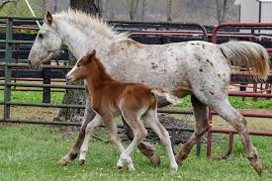

GROUND RULES
of the
ANACONDA SADDLE CLUB, INC.

- Annual Vaccination and Parasite Control Policy: All horses on Club property must have proof of annual vaccinations and at least quarterly de-worming, and be recorded with the Corporate Officers. Reporting procedures for all members' horses include, a dated copy of either a vet record or proof of purchase of vaccine and de-wormer, and must be provided by the member by June 1st of each year. Records may be mailed, brought to a meeting, or placed in the Vaccination Box at the clubhouse. A list of delinquent vaccinations/de-worming will be posted at the clubhouse. Corporate Officers will maintain a list of necessary vaccinations as recommended by local veterinarians. Any exceptions to the annual vaccination policy must be apporved by the Corporate Officers and may require a veterinarian’s written order.

Members bringing “new” horses to the Club must provide proof of vaccination to the Corporate Officers prior to or upon entering the Club grounds, or the horse must be removed. Non-member horses being housed at the Club, by either a member or overnight/event, must have proof of vaccine upon entering the Club grounds.

- Quarantine and Visiting Horse Policy: Members bringing a “New” horse(s) to the Club Property must be confined to the member’s barn or designated area for 21 days (3 weeks) to prevent spread of possible contagious disease. Members “Returning” a horse(s) to Club property with current vaccinations and health record, and exhibiting no signs of contagious diesese may be returned without a quarantine period. Visiting horses, in order to prevent spread of contagious disease, should be free from obvious disease.

- Pasture Policy: Pastures are intended for exercise only and are not considered adequate for nutritional care of horses; therefore, even when horses are turned out in Club pastures they still must be fed each day. Upper and lower pastures are used on an “even-odd” schedule; even days of the month are for geldings and odd days for mares. Months having 31 days allow mares an extra day. Upper and lower pastures will be closed from April 1st through June 1st of each year and at designated times when deemed appropriate by the corporate officers and or membership. The pasture rotation schedule will be posted on the bulletin board and pastures.

The small front pasture will be available to turn horse(s) out during cleaning and or repair of barns. There is a 2-hour time limit on the use of this pasture unless otherwise posted. Members using this pasture must be on the grounds and accessible. Other members wishing to share the small front pasture must ask permission of the member who is using it first before any additional horse(s) are turned out together. This pasture will remain open while the upper and lower pastures are closed and posted when it will be closed. Pastures are only to be used for member horses housed on the ASC grounds and then only if compliant with the Annual Vaccination and Parasite Control Policy. Members bringing horses in for a day will be required to use the pens at the arena or another member’s barn with their permission.

Pasture closures will be posted on the bulletin board, please check frequently for up-dates. All horses must be returned to their barns by dark.

- Canners and Trade Stock: All canners and trade stock that enter the Club grounds must have a vet inspection, be vaccinated, and kept in the owner’s barn while on Club property. Any horse not owned by a member that is in training or being housed by a member temporarily cannot be turned out in the pastures.

- Sick or Injured Horses: Horses with any contagious disease, ill health, or injury will be kept in the owners barn or designated area until completely well.

- Sharp Shod Horses: No horses that are sharp-shod will be turned loose on the Club grounds.

- Riding Horses on Club Property: Horses are to be ridden at a walk in a quiet manner on the immediate Club grounds. This means from the south fence to the north barns and from the Clubhouse to the east fence below the blacksmith’s shop. Riders under the age of 18 must wear a helmet unless a parent or guardian has signed and submitted a waiver to the corporate officers or event organizer.

- Horses Housed on Saddle Club Property: Anyone keeping a horse at the Club must be a member. Members are required to give proper care, feed, water, and exercise to their horse(s). Any complaints or concerns about the health and/or care of any horse being housed on the ASC, Inc. grounds shall be reported to the corporate officers. The corporate officers will notify the member who is responsible for the health and/or care of the horse in question in writing. The member shall have 7 days to present a correction plan to the corporate officers. In the event the letter is not responded to, the correction plan cannot be agreed upon, or the correction plan is not followed officials/law enforcement will be notified by the ASC corporate officers. In the event the situation is not resolved to the satisfaction of the corporate officers the membership will be terminated.

When deemed appropriate by the membership at a regular meeting, the corporate officers shall have the authority to order a vet check for any horse housed on the ASC, Inc. grounds at the expense of the owner. Member will not be in good standing until paid. Members not in good standing will be denied use of the pastures, arena, round corral, clubhouse, and voting privileges until paid in full.

No more than two (2) horses per barn/pen. All horses are to be kept in barns at night.

- Taking Horses to and from Pastures: All horses when put in pasture for the day must be led and in control, and returned the same way, and not let to run loose between fences at any time.

- Unattended Horses: Horses are not to be left out of the owner’s barn unattended at anytime unless they are turned out in the pastures.

- Care of Barns: Barns and corrals must be kept clean at all times. Painting and maintenance of barns is required. The ASC, Inc. is listed on the “National Register of Historic Places;” thus, all barns new or remodeled must conform to the design and look of the existing barns. Each member is responsible for the maintenance of his or her barn/pen including water supply. Members will be notified in writing of any required maintenance. If not addressed in a timely fashion the corporate officers will take corrective measures and will assess the member for any costs associated with resolving the situation. Members will not be in good standing until paid. Members not in good standing will be denied the use of the pastures, arena, round corral, clubhouse, and voting privileges until paid in full.

Barns are not to be used as storage units and cannot contain any hazardous materials.

- Water Supply: Water supply facilities will be kept in good condition and not allowed to run into your neighbors corral. If water is running into adjoining corrals, the member responsible must repair it at once. If the member creating the situation does not take care of it immediately the corporate officers will take corrective measures and will assess the member for any costs associated with resolving the situation. Members will not be in good standing until paid. Members not in good standing will be denied the use of the pastures, arena, round corral, clubhouse, and voting privileges until paid in full.

- Disposing of Manure and or Straw: When disposing of manure and or straw, it is to be hauled to the lower pasture and dumped in a designated area. No trash including twine is to be dumped with manure and straw. Should it become necessary to scatter manure to restore grass in certain areas members will be notified of such.

Any member caught dumping trash, twine, or any other objects that can cause injuries to horses will be responsible and can be subject to loss of pasture use and/or membership. Members are responsible for hauling any trash too large for the dumpster to the landfill.

- Smoking: Smoking around barns is prohibited. No burning of any kind is allowed around barns.

- Use of Club Property: Any person or persons using the Saddle Club grounds must be a member. Exceptions include occasional guests and people coming for specific activities and events. However, any non-member using Anaconda Saddle Club property must sign a liability release form and file it with the Club secretary.

- Round Pen: Use of the round pen shall be limited to 45 minutes per session.

- Stallions: Stallions over 15 months or younger displaying stallion actions must be kept in a pen capable of safely containing the horse. Adjacent barn owners shall be notified before a stallion comes onto Club grounds and agree to the construction of any such stallion pen. The Club will not be used as a breeding facility, therefore, breeding of outside mares will not be allowed.

- Clubhouse Policy: Any member using the clubhouse is responsible for its care and condition. The clubhouse will be left clean and locked. Children under the age of eighteen (18) must be accompanied by an adult while in the clubhouse.

- Driving on Club Property: Vehicles entering Anaconda Saddle Club property must be driven in a slow and safe manner. Motorcycles, bicycles, and ATVs can be used only as transportation to and from members’ barns, however, for safety concerns they will not be allowed to be used for recreation on Club property.

- Tank heaters: Members keeping horses at the Club during the winter and using tank heaters will be responsible for the cost to operate these heaters. The corporate officers will determine fees. Members must report to the corporate officers the date they start using the tank heater and the date when the heater is unplugged or removed. It will be the responsibility of the member using the tank heater to make sure it is installed properly and used safely.

- Overnight policy: Travelers requiring horse accommodations must contact a Club officer, whose number will be posted. All horses entering the Saddle Club must have proof of current vaccinations and health certificates including a negative coggins test for out of state horses. Travelers can use the pens by the arena.

- Trailer Space: All trailers will be kept in designated areas unless making repairs or training horse(s) to load. Members can rent space in the covered trailer area as it becomes available. Selection of available trailer spaces in the covered trailer area will be done by a random drawing of all members who want to rent the space.

- Junk or abandoned vehicles: Owners will be given written notice to remove the vehicle. After 30 days, the vehicle will be towed at the owner’s expense.

- Arena Policy: The arena will be available for riding at all times. If the arena is not being used for riding, members may use it to turn out horses only if they are on ASC grounds and accessible to other members. Loose horses must be removed at once if a member wants to ride in the arena. The arena will be available for special events. Those proposing to use the arena for a special event must contact the Corporate Officers and make arrangements.

- Cats: Members who have barn cats must have them spayed or neutered and vaccinated for rabies. The Anaconda-Deer Lodge County Animal Control Officer will be contacted to remove feral and/or nuisance cat(s).

- Barn Area: Each member is responsible for the maintenance of the area around their barns including the grooming of any grass and control of weeds. The only items to be kept in the area are a wheelbarrow, manure trailer/spreader, and bench/chair. Items, which have been deemed inappropriate, if not removed in a timely fashion, will be disposed of.

- Helmet Rule: Riders under the age of 18 must wear a helmet unless a parent or guardian has signed and submitted a waiver to the corporate officers or event organizer.

